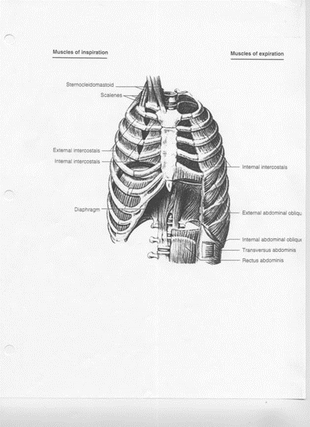
Summary of events during inspiration
the diaphragm is innervated by phrenic nerve.
Inspiration:
The mechanics of breading:
Diaphragm and intercostal muscles contract
- Increase the size
- Diaphragm goes down => longitudinal increase.
- Diaphragm is attached to the ribs, so lower ribs are moving upward. => cross section increase
↓
Thoracic cage expands
↓
Intrapleural pressure becomes more negative
- Due to the pleural space coupling. if you pull the chest. Plueral space contain non-expandable fluid , you pull the fluid => pressure of fluid decrease. The intrapleural pressure become more negative. (It is already negative in the beginning)
↓
Transpulmonary pressure increases
- (Transpulmonary means the pressure across the lung = difference between pleural space and inside the alveoli.) The pleural pressure is decreased (more negative.)
- Here we means the difference increases.
↓
Lungs expands
- If we decrease the pressure around the lung, this will pull the lungs open.
- Like you pull the plunger (decrease the pressure around the balloon, the balloon will expand. )
↓
Alveolar pressure becomes subatmospheric
- If you expand the lung ➔The air molecule has more space, decompress the gass. So the alveolar pressure (the pressure inside the lung) become less than beginning. (In the begging, the pressure inside and outside is the same)
- It become subatmospheric (negative to outside) This create pressure gradient and air come from outside to inside.
↓
Air flows into alveoli
Summary of events during expiration: the opposite of breath in.
Expiration:
Diaphragm and external intercostal muscles stop contracting
- The muscle stop contracting and relax.
↓
Chest wall moves inwards
↓
Intrapleural pressure goes back towards preinspiratory value
- Value go back to the value of before the inspiration
↓
Transpulmonary pressure goes back towards preinspiratory value
↓
Lung recoil towards preinspiratory volume
- You don’t pull lung anymore: lung recoil (think it as balloon)
↓
Air in lungs is compressed
↓
Alveolar pressure becomes greater than atmospheric pressure
↓
Air flows out of the lungs
ventilation is today’s focus.

Spirometry: Measuring lung volumes
Spirometer is nothing more is a volume of air floating above water. The tube is connecting the air space to subject. (The subject has a nose clip, and breathe through the mouth.)
To measure:
- If subject breath out. The air than go to the space. Container moves up => pen will go down
- If subject breath in. Breath from the space. Container moves sown => pen will go up
- You measure the volume of the air that subject breath in and out.
- Tidal volume: is the volume you breathe at rest. This is the amount of air goes in and out during the breath. ( This is the volume change when inspiration + expiration)
- Function Residual Capacity (FRC): When you breathe out at rest, you didn’t expire all the air in lung. There is still air in lung at the end of normal breath. (about 3 L) WHY?
- You still have blood flow around alveoli between breath. This air allows you to keep on the gas exchange.
- If the alveoli collapse (no air left), you will be difficult to breath in. (Need to breathe in the enormous amount.)
- Total lung capacity (TLC): If we breathe in as much as we can (deep breath.) This is the total air that can be included in your lung.
- Residual volume (RV): If you try to make a huge effort in breathing out. Contract the muscle to try to breath everything out. You reach residual volume. This small amount of air is still left at the end of expiration, your alveoli don’t collapse.

- This is more detail.
- Inspiratory reserve volume: From Tidal volume to maximum volume is the reserve volume.
- expiratory reserve volume: Functional residual capacity to residual volume is the reserve volume.
- Vital capacity: From total lung capacity to residual volume. clinical used.
- Inspiratory capacity: From functional residual capacity to total lung capacity.

- Back to the spirometry picture.

- This allow you to measure the volume that are breathe in and out.

- Spirometry can’t measure the volume: FRC! (This is inside the lung, not breathe out!)

- RV and TLC also can’t be measured.

The trick: Measurement of FRC: helium dilution techniq

- Dilute helium in the gas to the whole system. (You know the C1 and V1)- you built them up.
- Ask the subject to Breathe out (reach FRC)
- Open up the system to allow helium can pass through.
- Subject than breathe in and out the system a few times. => The helium concentration will then have diluted to the lungs => New concentration (C2) and new volume (V2 – FRC + system)
- This new concentration can be measured with:
C1 x V1 = C2 x (V1 + FRC) (V2= equipment +FRC)
so that:
FRC = (C1 x V1 / C2) - V1
Note: Think of the lung as a balloon not as a jar. When subject breathe out to FRC, the Lung is like a balloon, the FRC is in the lung (The lung is not like a jar and FRC is not a fluid that sink in the bottom, it is a whole thing in lung= FRC.)
VENTILATION
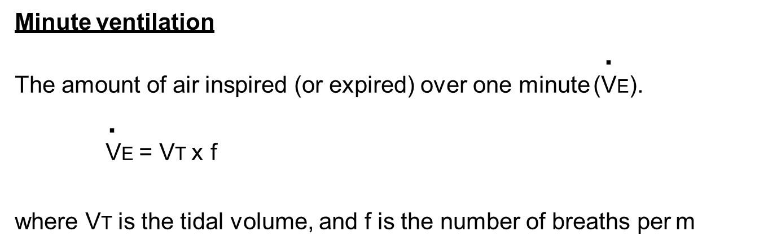
-ventiliation is about volume and the number of breath (frequency)

- The dot on top of VE refers to per min (per time) => called the minute ventilation.
- VE = the tidal volume * the frequency
- However!!
- Not all the air inhaled into the lungs reaches the gas exchanging area(the alveoli region). Some of the air remains in the conducting airways (anatomical dead space). – the is some air never participate the gas exchange because it never reaches the alveoli region ( reaches the conduction zone)
- Refer as anatomical dead space. (the region don’t participate the gas exchange)
- We need to account this when we want to tell Ve of subject.
- Follow is an example.
- Assume that subject have a tidal volume of 450ml.
- The purple structure on the left is the FRC.
- The orange is the fresh air with oxygen.
- The 150 ml is the Anatomic dead space (conducting space.)
- when the subject breath in the tidal volume. There will always be some air that stays in conducting airway that doesn’t participate the gas exchange. The subject will breath out, air will go out. However the conducting zone air will be breathe out and doesn’t patriate gas exchange.
- Need to subtract the part not did not contribute.
- The anatomical dead space is normal not a pathological situation
- The volume of the anatomical dead space in the adult subject is about 150mL (anatomical dead space is difficult to measure, but a close approximation is a subject's weight in pounds).
- If the subject weight 150 pounds, the anatomical dead space can be 150ml.

- Subject with 500 ml of tidal volume.
- (breath in frequency) = 12/min
- Ve= 500 *12 =6000. ( This is min ventilation)
- We want to know the actual Alveolar ventilation. You need to remove the dead space.
- If subject is 150 pounds. You remove 150 ml.
- Therefore, The volume of the anatomical dead space in the adult subject is about 150ml. Thus, the amount of air that reaches the respiratory zone per minute and available for gas exchange, the alveoli arventilation (VA), is:
- VA= (500-150 ml) x 12= 4200 ml/min
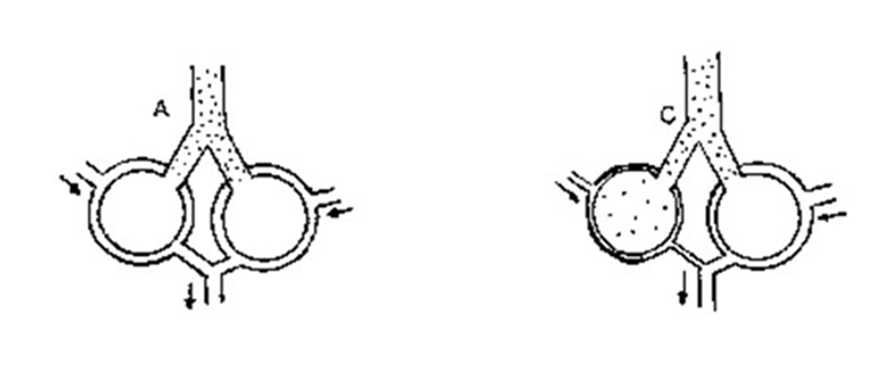
- Active volume * breath in frequency = Alveolar ventilation.
Pathological: Alveolar dead-space.
- The pic shows that when airs go to both lungs => gas exchange (left pic )
- When you have a blood clot, no blood exchange or reduced blood exchange. (right pic)
- Aleolar dead space: occurs in alveolar region.
- Think the example, ppl with blood clot in blood vessel.
- Blood doesn’t flow around the capillary around the lung area.
- Air reaches alveolar region but no gas exchange because of blot clot (clot in blood vessel)
- This is call alveolar dead space: This is pathological (in elderly/ pathology, normally not in young ppl)
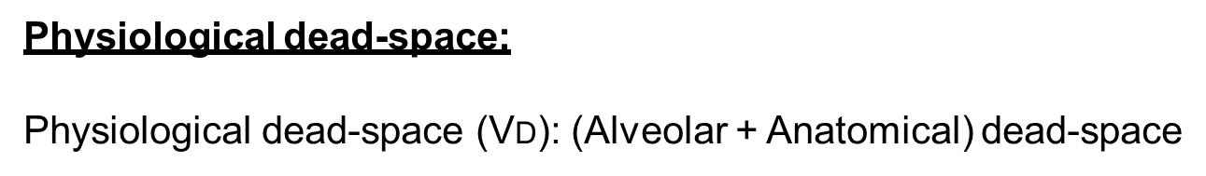
- Alveolar dead-space: under some pathological conditions, a certain amount of inspired air, although reaching the respiratory
- Physiological dead space is the sum of Alveolar and anatomical dead space.
- In a normal young person: VD= VA(anatomical dead space)
- VD (dot) = VE( dot) -VA (dot)
- ➔ the dead space ventilation = the minute ventilation – the anatomical ventilation.
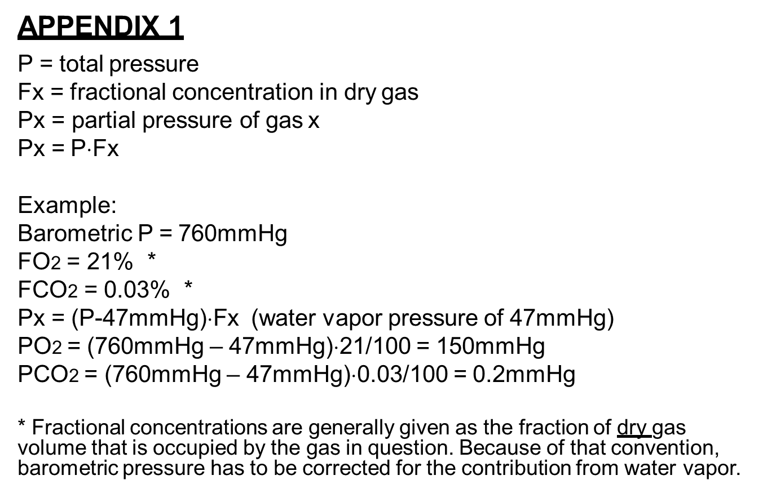
APPENDIX 1
Total pressure is call P= 760mmHg. (VP) – the barometric pressure
The concentration of oxygen in the air we breathe: 21% in the total gas.
- What is the pressure of oxygen : 760 mmHg* 21%
- Same with CO2( 0.03%)
- However, these air measured in dry lab. (the gas is dry gases.) We breathe water vapor in real life.
- Substrate 47 mmHg water vapor =➔ this is the PX (the partial pressure)
- The new equation of oxygen: (Ptotal -47mmHg) * 21/100 =150mmHg.
- This slide show the pulmonary cardio systemic system.
PO2 and PCO2 are slightly different but this is fine.
- You take a breath in. -> bring fresh air in.
- Have gas exchange around alveoli. ( O2 goes into the capillaries , CO2 goes out the capillaries.)
- PO2 =105, PCO2 =40 mmHg inside the lungs.
➔ different from outside pressure do to the gas exchange.
- The blue blood from vena cava that is deoxygenated ( high Co2)
➔ PO2: oxygen diffuse from the alveoli to the capillary because the pressure gradient ( 105 -→ 40mmhg) GO DOWN THE PRESSURE GRADIENT.
➔ At the end of capillary. PO2 = 100 mmHg. This go via pulmonary artery and back to the left heart into the systemic artery.
➔ CO2: CO2 is high in deoxygenated blood, you get diffusion in opposite direction ( 46 (in capillary) → 40mmHg (Alveoli)) The PCO2 is 40 mmHg go via pulmonary vein and back to the left heart.
Key: Gases diffuse down the pressure gradient.
The high O2 and low CO2 go to the systemic blood to brain, cell in need( ex: muscle cell)
- The cell used O2 and produce CO2.
-➔ The oxygen diffuse from the capillary into the cells . The CO2 diffuse from the cell to the capillary.
➔ PO2 decrease , PCO2 increase. In systemic vein
- Go through the vena cava go back to the heart.
- The pulmonary capillary bring the blood to be oxygenated at the lung level .
- We often refer the red color blood on the right as artery blood, and the blue color blood as Venus blood.
➔You call it artery blood but it is Pulmonary vein.
➔ You call it Venus blood but it is pulmonary artery.
- This terminology is a systemic point of view. ( ex: Pulmonary vein and systemic artery have the same blood pressure, that’s why we refer it as arterial blood)
You will not be confused by this in the exam.

Normal Alveolar Ventilation: VA (alveolar ventilation) matches CO2 and keeps PaCO2 (arterial CO2) at a constant level.
A=>ARVEOLAR
a=> arterial
You will see A v.s. a all the time.
- It is controlling CO2
- Normal ventilation = Normal CO2: is when ventilation is adequate to maintain CO2 at the constant level.
- Alveolar hyperventilation: This occurs when more O.2 is supplied and more CO2 removed than the metabolic rate requires (VE exceeds the needs of the body). As a consequence, alveolar and arterial partial pressures of O2 rise and those of CO2 decrease.
-------------When you have more O2 supply to the lungs , more CO2 remove from the lungs then what you needed for metabolism.
----------------- If you have more in alveolar ➔ have more in artery level. You are able to quantify at the alveolar level and at the blood.
- Note: This is with respect to metabolism so not as during exercise.
We are not hyperventilation during exercise, because we increase ventilation and metabolism at the same time.
- Hypoventilation: A fall in ventilation can reduce alveolar
ventilation below that required by the metabolic activity of the body.
- Under such conditions, the rate at which O2 is added to alveolar gas, and the rate at which CO2 is eliminated, is lowered, so that the alveolar partial pressure of O2 (PAO2) falls and PACO2 rises.
- Therefore, PaO2(arterial) falls below normal values and PaCO2 rises above the normal value. Reflect at the blood level.
- Alveolar hypoventilation may occur during severe disorders of the lungs (e.g. chronic obstructive lung disease), or when there is damage to the respiratory muscles. It can also occur when the chest cage is injured (pneumothorax we talk abt before) and the lungs collapse, or when the central nervous system is depressed.
------------A fall in ventilation that is below than the need.
-------- happen when disease
practice the diagram

